HOTEL INFORMATION
The Scandic Bergen City Hotel is our hotel of choice. Rooms have already been pre-booked. For your convenience, the conference will also take place at the hotel.
Hakonsgaten 2
5015 Bergen
Norway
Phone: +47 55 30 90 80
Fax: +47 55 30 90 91
TRANSPORTS

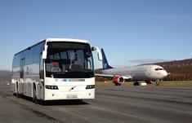
At the airport, you will find the Airport Express Coach (Flybussen) outside the arrival area. The bus goes towards the city center. During the day, there is a departure every 15 minutes (Saturdays every 20 minutes). Late at night there are departures approximately every 20 minutes. You will need to tell the bus driver to drop you off at the Scandic Bergen City Hotel.
Cost is: 11.80€
You can also take a taxi ito the hotel: Bergen Taxi Company.
Telephone : 55 99 70 00
Email : info@bergentaxi.no

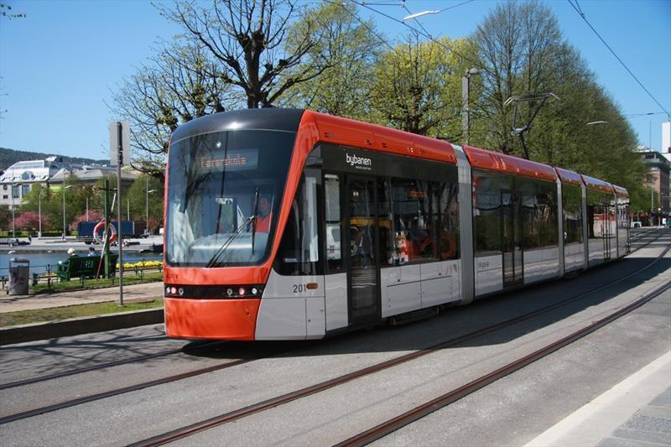To get around within the city center, the tramway is widely available !

